Task 1: Block Inbound Port 8080 In Windows Defender Firewall

Steps:
- Press Windows + R → Type wf.msc and press Enter.
- Select Inbound Rules → Click New Rule.
- Select Port → Next → Select TCP.
- Select Specific local ports and enter:
8080
- Select Block the connection → Select Domain, Private, and Public.
- Enter the rule name:
Block Incoming Port 8080
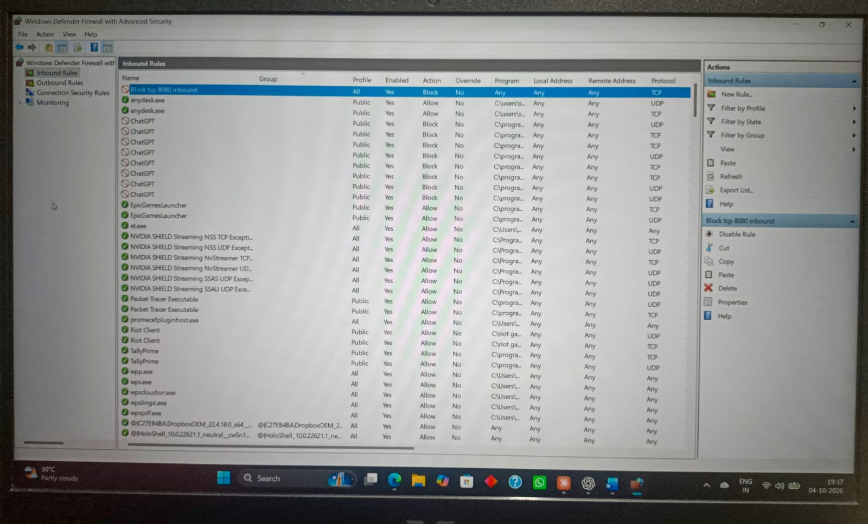
- Click Finish.

Task 2: Network Address Translation (NAT / PAT) Simulation

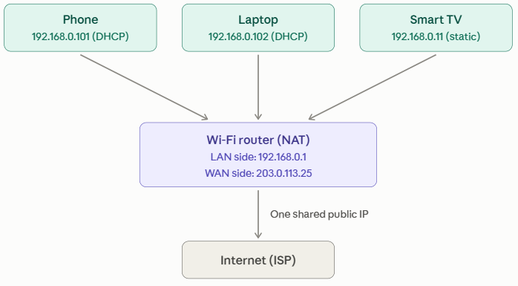
- Each device gets a private IP from the
router's DHCP server (phone .101,
laptop .102, smart TV .11 static).
Private addresses (192.168.x.x) are not
routable on the internet.
- When a device sends traffic out, the router replaces
the private source IP with its single public WAN IP and
assigns a unique source port. This is NAT with port
translation (PAT).
- The router records each translation in a NAT table. When the reply comes back, it looks up the port, restores the correct private IP and forwards the reply to the right device.
- Outside hosts only ever see the public IP, so the internal addresses stay hidden and unsolicited incoming connections are dropped by default. This is why NAT acts as a basic security layer.

Task 3: Router Port Filtering (Blocking Outbound Port 25 / SMTP)

Configuration Walkthrough (Home Wi-Fi Router Admin Panel)
- Open a browser and navigate to your router default gateway (e.g., [http://192.168.1.1]).
- Go to Security $→$ Access Control (or Firewall $→$ Port Filtering / Outbound Filtering).
- Click Add Rule / New Filter:
- Rule Name: Block_Outbound_SMTP
- Source IP: Any (or 192.168.1.0/24)
- Protocol: TCP
- Destination Port Range: 25 to 25
- Action / Policy: Drop or Block / Reject
- Click Apply / Save and restart the firewall service if prompted.
Explanation: Malware on an infected device often sends spam by connecting directly to remote mail servers on port 25, so blocking outbound port 25 stops it from sending bulk email from your network. Legitimate email can still go out through your provider's authenticated mail submission port (587), which also helps keep your public IP from being blacklisted for spam.

Task 4: Packet Filtering Rule Set Evaluation

Method: firewall rules are checked from top to bottom and the first matching rule decides the outcome. If none match, the default (implicit) deny applies. For each packet, compare source IP, destination IP, protocol and destination port against each rule.
Assumed example rule set:
- Allow TCP, source 192.168.1.0/24, any destination, port 80 or 443
- Allow UDP, source 192.168.1.0/24, any destination, port 53
- Deny TCP, any source, any destination, port 22
- Deny all (implicit)
Results against this example:
- HTTP from 192.168.1.5 to 172.217.166.78:80 is allowed. The source is inside 192.168.1.0/24 and TCP port 80 matches rule 1.
- SSH from 10.0.0.10 to 34.201.23.1:22 is blocked. The source is outside the allowed subnet, and TCP port 22 matches the deny in rule 3.
- DNS from 192.168.1.7 to 8.8.8.8:53 is allowed. The source is in the subnet and UDP port 53 matches rule 2.
Task 5: How High-Traffic Platforms (Instagram & Zomato) Deploy Firewalls & Packet Filtering

- Web Application Firewalls (WAF) for Application-Layer (Layer 7) Protection

Platforms like Instagram and Zomato route edge web and API traffic through Layer 7 WAFs (such as AWS WAF, Cloudflare Magic Firewall, or Akamai Kona). Unlike traditional network firewalls, WAFs inspect the HTTP/HTTPS request bodies to detect and drop attacks such as SQL Injections (SQLi), Cross-Site Scripting (XSS), credential stuffing, and bot scraping against restaurant menu APIs or user account profiles before the requests reach internal backend microservices.

- DDoS Mitigation via Volumetric Stateless Packet Filtering (eBPF / XDP & Scrubbing Centers)

During sudden traffic spikes—such as midnight food orders during major cricket tournaments on Zomato or viral video uploads on Instagram—infrastructure faces potential Layer 3/4 Distributed Denial of Service (DDoS) flood attacks (e.g., SYN floods, UDP amplification). These platforms run kernel-level packet filtering using eBPF (Extended Berkeley Packet Filter) and XDP (eXpress Data Path) directly at the network interface card (NIC) driver level. Malformed or blacklisted packets are discarded without invoking the OS kernel network stack, absorbing hundreds of millions of packets per second.

- Zero-Trust Micro-segmentation & East-West Internal Network Firewalls

Within their cloud clusters (Kubernetes / AWS VPCs), backend systems are strictly segmented. Instagram and Zomato employ internal stateful packet filtering and security group ACLs that prevent lateral movement between application layers. For example, user-facing search and feed pods can only communicate with payment or database clusters over strictly defined ports (e.g., PostgreSQL port 5432 or gRPC), and database servers are forbidden from initiating outbound connections to the public internet.

